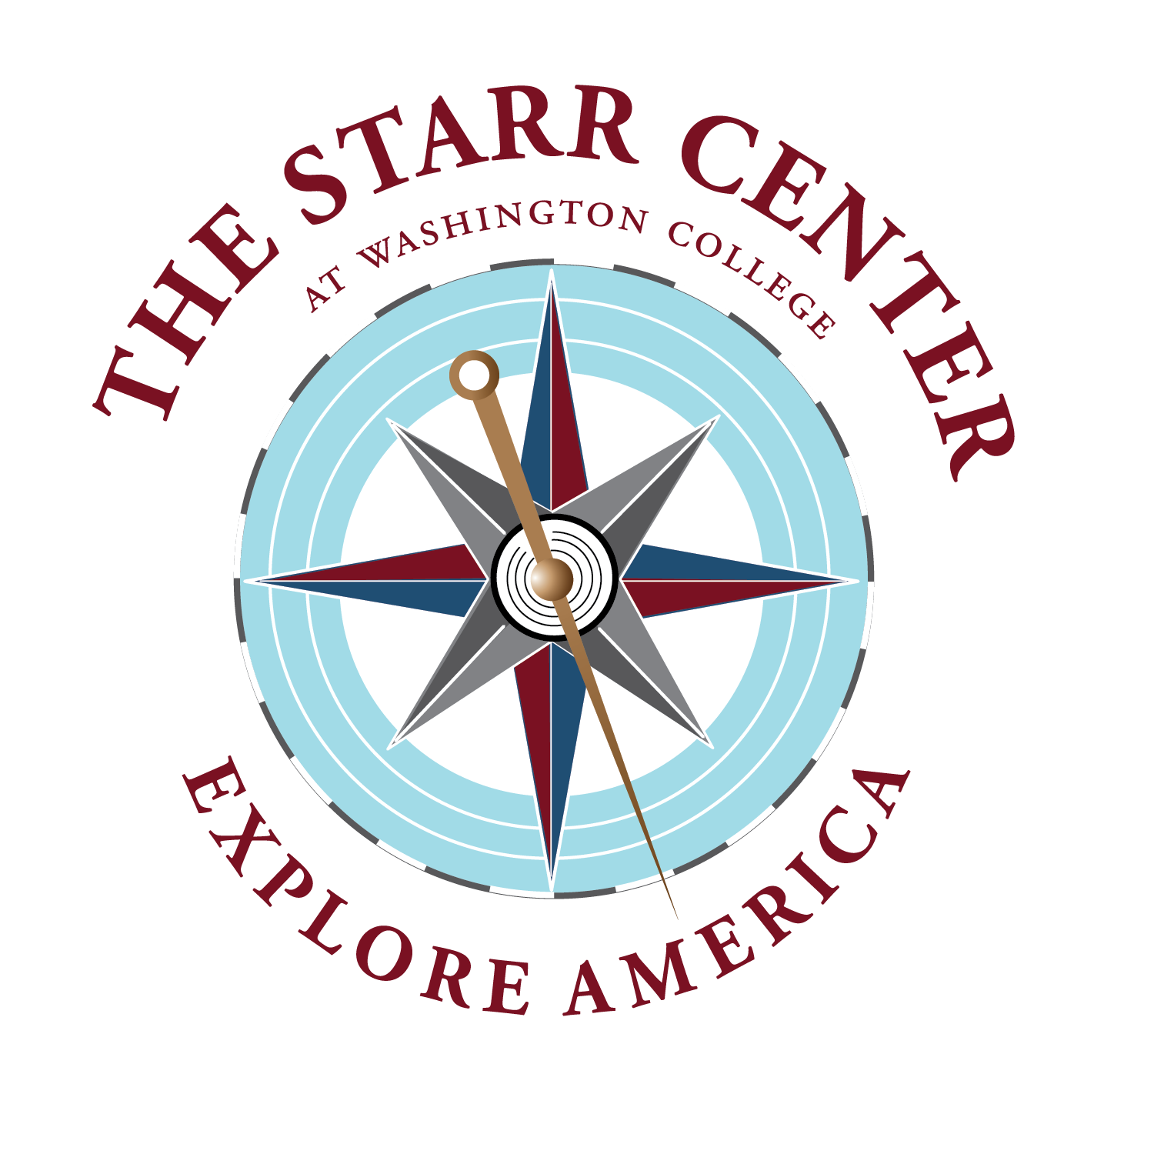

Explore America Summer Internship Application

Applicant’s name:

Applicant’s phone number:

Washington College Current Class Year:

Major/Minor:

Names of three references whom we can contact. At least two must be Washington College faculty. For non-WAC references, please also provide the person’s professional title.

1.
Name/email/phone:

2.
Name/email/phone:

3.
Name/email/phone:

Desired internships (selected from here), ranked in order of preference. You may be considered for multiple positions. You may list as many as you wish, and we encourage you to list several.

Applications must also include a cover letter, résumé, and academic transcript.
More details are on our website.

