FOUNDED 1782
300 WASHINGTON AVENUE, CHESTERTOWN, MD 21620-1197

STANDARD OPERATING PROCEDURE NO. 13 ZEBRAFISH BEHAVIORAL ASSAYS

Zebrafish have become a highly valuable and useful vertebrate animal model in the field of behavioral neuroscience. They are particular useful in that their nervous system shares many physiological characteristics with other common mammalian vertebrates such as mice and rats that are commonly employed by investigators. Like mice, there are also wide ranges of mutant and transgenic strains of zebrafish that are available to investigators. The following guidelines were develop for two common zebrafish behavioral assays,

Scitoaxis is the tendency to avoid brightly lit regions in preferences for regions that are poorly illuminated or dark. Generally, adult zebrafish exhibit scototaxis, presumably because they may be vulnerable to predation in similarly illuminated areas in their native habitat. Scototaxis may be
used as an assay of states that may be similar to “anxiety” or traits similar to “boldness” in humans.

Investigators have also employed the Novel Tank Test as a behavioral assay of anxiety/boldness. Adult zebrafish typically distribute their time relatively evenly between the top half and the bottom half of the novel tank. However, when anxious (e.g., exposed to the image of a predator or alarm chemosignals that originate from injured conspecifics, they spend a greater proportion of time in the lower half of the tank.

Both assays may be useful as assays of the general health of the fish.

Scototaxis Behavioral Assay in Zebrafish

Adult zebrafish (Danio rerio) of mixed gender are used for this experiment. These fish are group housed in tanks containing 5-­‐10 fish, separated by sex located in the Aquaculture Facility. A circulating filtration system was used to keep the water in proper conditions. The tanks were kept at a temperature of about 25-­‐28°C and had a 14/10 hour light/dark cycle; lights on at 0700 hrs (Blaser & Rosemberg, 2012). The fish were fed 1-­‐2 times per day.

1. Prepare Black/White experimental tank and camera (Stewart et al., 2012; See Figure 1):
A. Cover the outside of half the tank with white paper and the other half with black paper
B. Place white paper with two black circles in adjacent corners under the tank along the white side
C. Place this setup over the LED cool-­‐light box so that the black portion of the tank is to the left, directly over the opaque black surface of the jig-­‐table. [When properly position the tank should rest against the two wooden rails on the jig-­‐table.]
D. Fill this with warm water from the zebrafish tank system up to 6 cm
E. Set up a top down camera above the tank connected to a television or recording software F. The room lights should be off, and window shades drawn

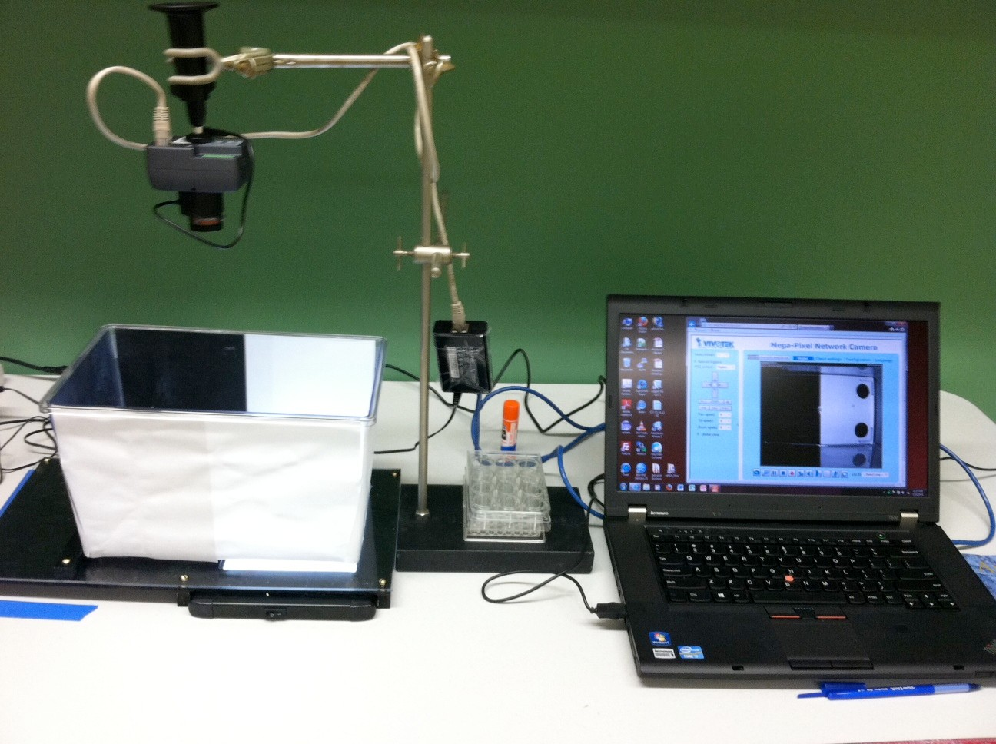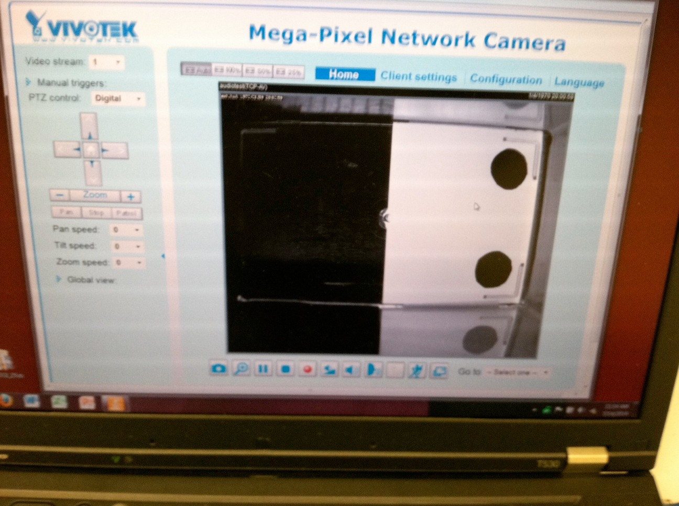Figure 1. [LEFT] Proper configuration of the Black/White scototaxis/boldness tank for video recording of the behavioral trials. Make certain the tank is positioned so that it fits precisely in the jig-table so that the cool LED light-source is directly below the illuminated side of the tank. [RIGHT] An image of the tank interior, half of which is darkened and the other half illuminated, as viewed from the video camera and digitally recorded. In this instance the illuminated portion of the tank also includes the two small dark circles that are employed in the tests of ‘Boldness.”

2. In the Aquaculture facility (SG113), move 3-­‐4 fish into a small (1 L) trapezoidal tank filled with system water and transport these fish to the testing area.
3. Fill several small (1 L) trapezoidal tanks for each fish with system water, and place dividers between these tanks so the fish are unable to see one another.
4. Using a net, place the fish in the separate tanks and wait least 30 minutes for them to acclimate to the new tanks (Blaser & Rosemberg, 2012).
5. Fill a recovery tank with system water and place an air-­‐stone in this tank.
6. Using a net, move one fish from its net into the black side of the experimental tank.
[Take caution that you do not place you hand or the fishnet over the bright portion of the tank as this will require the video system to re-­‐equilibrate before you can collect any recordings of the test session.]
7. If utilizing recording software such as Ethovision, go to step 7B, if not go to step 7A.
A. Using a stopwatch, measures the amount of time the fish spends in the white side of the tank and use a tally counter to count the number of times the fish crosses the midline (scheme). Record this behavior for 15 minutes. To account for the acclimation period, collect the data for the first 5 minutes and the last 10-­‐minutes separately (Blaser & Rosemberg, 2012).
B. Using recording software on a computer attached to the camera, press record immediately after placing the fish on the black side of the tank. Either manually, or using timer software [e.g., Auto Mouse Clicker 3.0 ], stop the recording after 15 minutes. Save this recording to import into Ethovision for analysis (http://www.noldus.com/animal-­‐behavior-­‐research/products/ethovision-­‐xt) (Maximino et al., 2012). [Identify each recording using a unique file ID and note this ID in the laboratory notebook]
8. Make notes about any unusual behavior(s) that occur during each trial.
9. A. If the fish are to be euthanized, follow the protocol approved for this purpose by the IACUC.

B. Otherwise, after the trial is complete, move the fish to the recovery tank using a net and repeat protocol (steps 6-­‐8) with the other fish. Keep the fish in the recovery tank with an air-­‐ stone for at least 30 minutes after the trial is complete to minimize the negative health effects of the stress induced by the test. Observe the fish during this recovery period and note any unusual behavior in the laboratory notebook. After 30-­‐60 minutes have passed, return the tested fish to their home tank.

10. Replace all of the water in the tanks with more system water before running additional trials. Check the temperature of this water to ensure it is within the safe range (25-­‐28 °C) for zebrafish (Stewart et al., 2012).

References

Blaser, R. E., & Rosemberg, D. B. (2012). Measures of anxiety in zebrafish (Danio rerio): dissociation of black/white preference and novel tank test. PLoS One, 7(5), e36931.

Maximino, C., Benzecry, R., Matos Oliveira, K. R., de Jesus Oliveira Batista, E., Herculano, A. M., Broock Rosemberg, D., ... & Blaser, R. (2012). A comparison of the light/dark and novel tank tests in zebrafish. Behaviour, 149, 10-­‐12.

Stewart, A., Gaikwad, S., Kyzar, E., Green, J., Roth, A., & Kalueff, A. V. (2012). Modeling anxiety using adult zebrafish: a conceptual review. Neuropharmacology, 62(1), 135-­‐143.

Novel Tank Test Behavioral Assay in Zebrafish

Adult zebrafish (Danio rerio) of mixed gender are used for this experiment. These fish are group housed in tanks containing 5-­‐10 fish, separated by sex. A circulating filtration system was used to keep the water in proper conditions. The tanks were kept at a temperature of about 25-­‐28°C and had a 14/10 hour light/dark cycle; lights on at 0700 hrs (Blaser & Rosemberg, 2012). The fish were fed 1-­‐2 times per day.

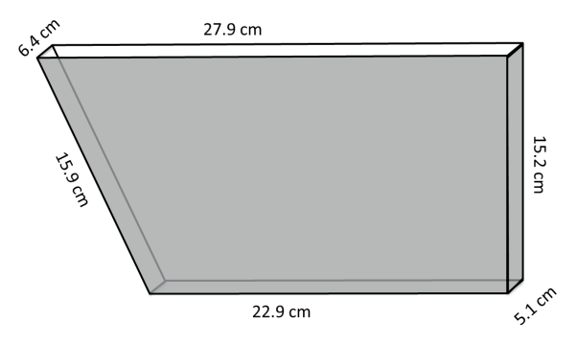1. Prepare 1.5 L trapezoidal “novel” tank and camera (Levin, Bencan & Cerutti, 2007; See Figure at Right). The back of the novel tank may be painted white or covered on the back by tacky white shelf paper to increase the contract between the fish and the background.
a. Place this setup 6-­‐24 inches in front of a cool LED light-­‐source so that the black portion of the tank illuminated.
b. Fill the novel tank with warm water from the zebrafish tank system until it can no longer hold any water.
c. Set up the digital camera in front of the tank so that the camera image of the tank fills the entire screen and connect it to a television or recording software running on a computer.
d. The room lights should be off, and window shades drawn.

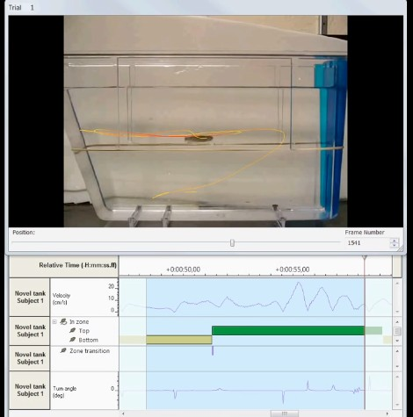Figure 2. Proper configuration of the “novel” tank for video recording of the behavioral trials. Make certain the tank is positioned so that the cool LED light-­‐source illuminates it from behind.

[TOP] An image of the tank and the path that the Ethovision Software produces illustrating the movement of the fish within the tank.

[BOTTOM] The visual summary of the automated data analysis performed by the Ethovision Software. Note that when properly configured, the software can quantify a number of behaviors, e.g., swimming velocity, distance traveled, time spent in the top and bottom of the tank as well as the number transitions between the top and bottom.

2. In the Aquaculture facility (SG113), move 3-­‐4 fish into a small (1 L) trapezoidal tank filled with system water and transport these fish to the testing area.
3. Fill several small (1 – 1.5 L) transfer tanks (a breeding tank can serve this function) for each fish with system water, and place dividers between these tanks so the fish are unable to see one another.
4. Using a net, place the fish in the separate tanks and wait least 30 minutes for them to acclimate to the new tanks (Blaser & Rosemberg, 2012). Place an air-­‐stone in this tank to oxygenate the water.
5. Fill a recovery tank with system water and place an air-­‐stone in this tank.
6. Using a net, move one fish from its net into the novel test tank. [Wait for the video system to re-­‐equilibrate and the image of the tank to stabilize before you can collect any recordings of the test session.]
7. If utilizing recording software such as Ethovision, go to step 7B, if not go to step 7A.

a. Using a stopwatch, measures the amount of time the fish spends in the top half of the novel tank and use a tally counter to count the number of times the fish crosses the midline (scheme). Record this behavior for 15 minutes. To account for the acclimation period, collect the data for the first 5 minutes and the last 10-­‐minutes separately (Blaser & Rosemberg, 2012).

b. Using recording software on a computer attached to the camera, press record immediately after the camera image has stabalized. Either manually, or using timer software [e.g., Auto Mouse Clicker 3.0], stop the recording after 15 minutes. Save this recording to import into Ethovision for analysis (http://www.noldus.com/animal-­‐behavior-­‐research/products/ethovision-­‐xt) (Maximino et al., 2012). [Identify each recording using a unique file ID and note this ID in the laboratory notebook]

8. Make notes about any unusual behavior(s) that occur during each trial.
9. A. If the fish are to be euthanized, follow the protocol approved for this purpose by the IACUC.
B. Otherwise, after the trial is complete, move the fish to the recovery tank using a net and repeat protocol (steps 6-­‐8) with the other fish. Keep the fish in the recovery tank with an air-­‐ stone for at least 30 minutes after the trial is complete to minimize the negative health effects of the stress induced by the test. Observe the fish during this recovery period and note any unusual behavior in the laboratory notebook. After 30-­‐60 minutes have passed, return the tested fish to their home tank.
10. Replace all of the water in the tanks with more system water before running additional trials. Check the temperature of this water to ensure it is within the safe range (25-­‐28 °C) for zebrafish (Stewart et al., 2012).

References

Blaser, R. E., & Rosemberg, D. B. (2012). Measures of anxiety in zebrafish (Danio rerio): dissociation of black/white preference and novel tank test. PLoS One, 7(5), e36931.

Levin, E.D., Bencan, Z., & Cerutti, D.T. (2007). Anxiolytic effects of nicotine in zebrafish. Physiology & Behavior,
90, 54-­‐58.

Maximino, C., Benzecry, R., Matos Oliveira, K. R., de Jesus Oliveira Batista, E., Herculano, A. M., Broock Rosemberg, D., ... & Blaser, R. (2012). A comparison of the light/dark and novel tank tests in zebrafish. Behaviour, 149, 10-­‐12.

Stewart, A., Gaikwad, S., Kyzar, E., Green, J., Roth, A., & Kalueff, A. V. (2012). Modeling anxiety using adult zebrafish: a conceptual review. Neuropharmacology, 62(1), 135-­‐143.

