CITI Program Registration Information
for Students/Faculty/Staff Conducting Research with Humans or Animals

Step by Step Guide:
1) Go to www.citiprogram.org.
2) Select the “Register” tab at the top right.
3) Type in “Washington College” in the box titled “Select Your Organization Affiliation.” Check the boxes to agree to the Terms of Service and to affirm that you are an affiliate of Washington College. Then click “Continue To Create Your CITI Program Username/Password.”

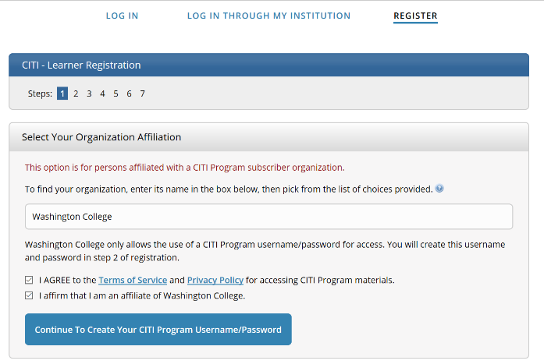

4) Complete the next several pages requesting information. Please use your washcoll.edu email address.
5) Continuing Education Unit Option – Assuming you are not completing the course for Continuing Education Credits (there is an additional fee for this), click “no” for each question with an *. Ignore the question without *.
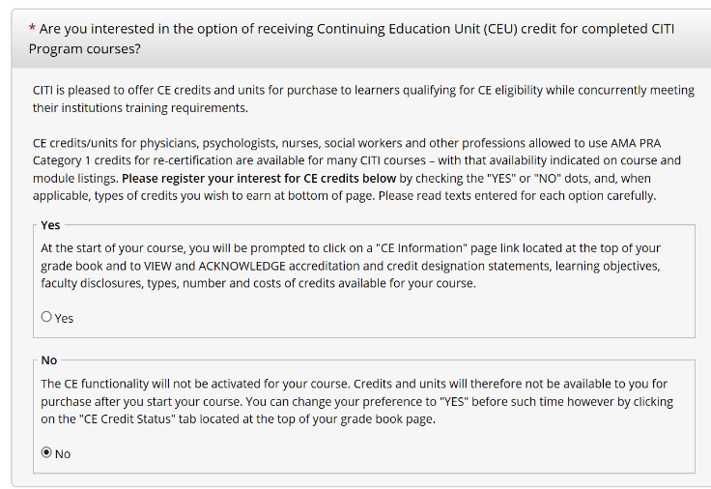

6) Fill in the additional required information (indicated by the *). For Department fill in your respective department/major (e.g., Psychology, Anthropology). For Role in Research click the appropriate option (students should select “student researcher-undergraduate”).
7) On the next page, a list of questions will determine which types of courses you would like to take.
- Question 1: Choose which learner group for the Basic Courses based on your role. For example, members of Faculty and Staff should select “Group 1: Principal Investigators – Faculty and Staff” and students should select “Group 2: Student Researchers”.

- Question 2: This only applies to the Institutional/Signatory Official (i.e., the Dean of the College) and the IRB Chair. All others should leave this blank.
- Question 3: Select “Public Health Research” if that describes the nature of your research. Otherwise, select “Not at this time.” There are a few additional models that are required for those conducting public health research (they are optional modules for everyone else).
- Question 4: This is for staff members who are handling data, who have been identified as “Colleague Users.” All others can select “I am not required to complete the IPS course at this time. (IPS stands for Information Privacy and Security)
- Question 5: This question is for those conducting research with animals. Anyone conducting research with animals is required to take the “Working with the IACUC” course and should select the first box. If you are not sure if you should select any additional options, you should contact your professor or advisor.
- Question 6: If you wish to access the free courses and have read the statement select “Yes”, if not select “No”.
8) When the registration is completed you should receive a confirmation email as well as an ID number (located in top right). Under Institutional Courses you will see Washington College. Select “View Courses.” You should see your courses listed under “Courses Ready to Begin.” Principle investigators should have 8 modules to complete; students should have 4 modules to complete. Click “Start Now” to begin. Example student view:
If you do not see the course you need, you can scroll down to the “Learner Tools for Washington College” and select “Add a Course.” This will take you to the list of 5 questions to determine which course(s) you need (as described in the previous step).
9) Click that you agree to the terms of service and click submit.
10) On the next page you will see the list of required modules that must be completed. You can take a module and then return later to complete other modules. Many modules have a short quiz at the end. You need to achieve an overall course grade of 80% to receive a completion certificate at the end of the course. You will also see a list of supplemental modules. These modules are optional. Depending on your type of research, you may want to take some of these additional courses. Please save your certificate to submit with your IRB or IACUC proposals.

