Registering Gaming &Guest Devices on ClearPass Guest Registration Portal

- Login into Clearpass Guesst Registration Portal using the link
https://clearpass.washcoll.edu/guest
- Enter your username and password. You can enter your username without @washcoll.edu
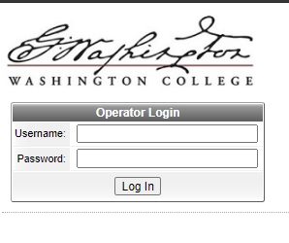
password
username

- After successful login, you will be redirected to device registration page.
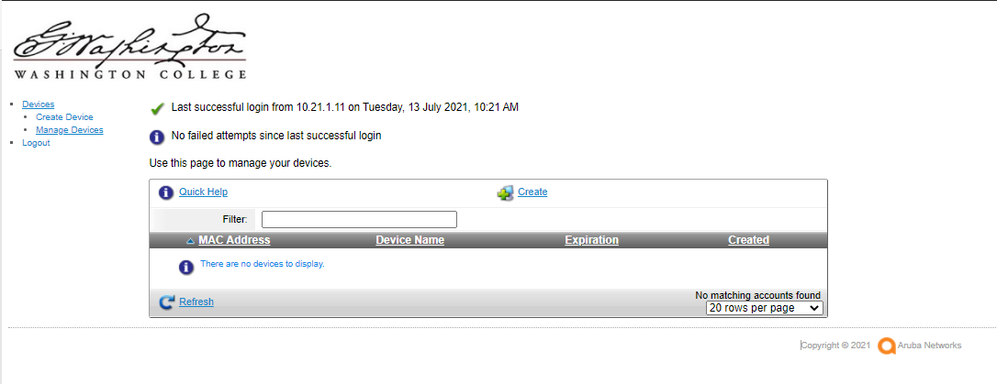
- Click on Create Device Tab.

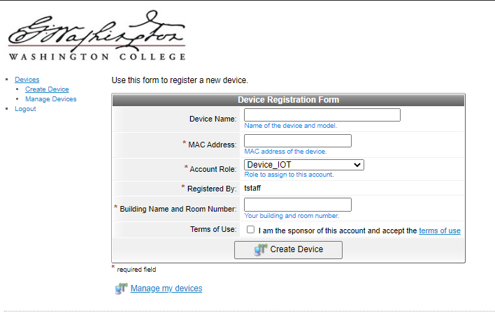

Device: Enter the Name of your device. Example:Test-Xbox
Mac Address: Enter the wired or Wireless MAC address here. Example: aa:bb:cc:dd:ee:ff
Account Role: Select Device_IOT
Registered By: It is set to your username by default.
Building Name and Room Number: Enter your Building name and room number here. Example: Minta_101
Terms of Use: Read the terms of use and Click the check box to register your device.
Then Click on Create Device.
- You can connect your device to a working ethernet port or WC Guest Wireless depending on the mac address you registered in the previous step. If you register your wired mac address, you can connect your device to Ethernet port. If you register your wireless mac address, you can connect to WC Guest Wireless.
- Manage Devices Tab:
You can manage your devices here. You can delete your device, you can view details of the device and you can edit your device.

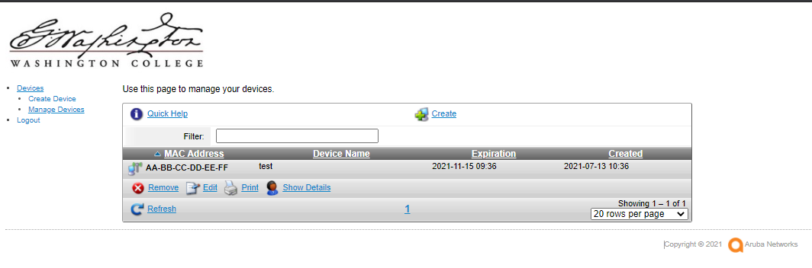

- You can check the expiration date of a device in the Show details tab.
- To remove your device, Manage devices Select the MAC address of the device RemoveDelete Account.
- Please contact Help Desk with any issues.

