How to Allocate/Code in Intellilink

What is Allocating/Coding?
It actual has two parts:
- entering the full accounting code
- entering the business purpose of the purchase (especially important for travel, meals, and non-supply purchases)
**
There are two ways to Allocate. (Hint: setting up favorites will speed the process)
You can code a transaction in either the Expense Reports area or in the Account Statement area. How to find those areas can be seen below:
Under the Expense drop down there are two items:
- “Branch banking and Trust” which brings you to the Account Statement- helpful if you want to do quick coding
- “Expense Reports” an alternative way to get to your expense report. (Tips Quickest Way is using the )
How to Code at the Transaction Level
STEP 1-Go to the transaction in either the Account Statement or Expense Report View
You can get to your transaction list in the Account Statement or the Expense Report. When looking at the screen below listing your transactions:
Click on the “X”
STEP 2-Selection the GL CODES DROP DOWN
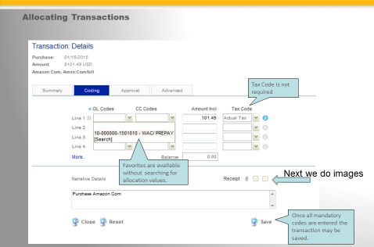
A new screen will pop-up
View should default to the Coding tab (highlighted in Blue on this image)

Select the drop down for GL CODES and the word Search at the bottom.
(you can split the amount into additional codes by using the next GL Codes Line)
STEP 3-FIND the correct Code
This screen will pop up. If you know your full code you can type it on the Code Value line and hit Search xx-xxxxxx-xxxxxxx
Don’t know the full code no problem there are two options
(Note: Everyone on campus has access to all the codes in Visa Intellilink)
If you have searched and cannot find a code email the Accounting Analyst II to add a new code.
*
For the Search feature the % sign is the wildcard
*
You can search by a partial number. Just put the % before and after, click the Search button and all object codes for that department will come up on the bottom for you to select from.
You can also search by name. This may be trickier because you need to know the official account name. On the Description line type the word with % on either side, click the Search button and your options will appear.

STEP 4-SELECTING THE CODE to add to your transaction
When you have the code you want to use you will need to select the upward arrow to place it in the transaction.

Save you transaction when it pops back to the main screen and you are done.

FAVORITES
HIGHLY RECOMMEND THAT YOU load the right up with your most frequently used codes. (Allowed up to 15)

This is easy and will make your life easier in future expense reports allowing you to skip STEP 3. To select a code for a favorite just use the RIGHT POINTING ARROW. You will see the code move to the right of the screen.
You can see the huge benefit below. No more selecting the Search option under the GL Codes, just click on the code you want and Save. You are done.

